RCL-O-PWR2 PWR Subsystem Overview
Saint Louis University
Rascal
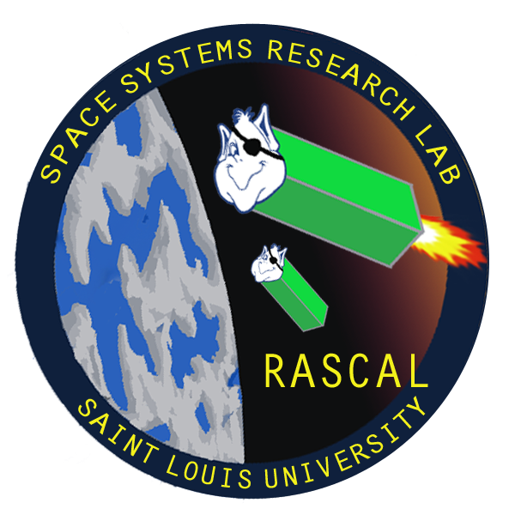

Last Updated: 11/7/26
Document No: RCL-O-PWR2

Prepared by:
 | Alexander Howard  Rascal Power Team lead |  | Date
Approval:
 | Dr. Michael Swartwout  Rascal Principal Investigator |  | Date

Revisions Summary

Revision | Description | Date | Prepared by | Approved by
0 | Document Created | 04/06/2014 | Alexander Howard
1 | "Risk of Future Work" added | 04/08/2014 | Alexander Howard
2 | Modified to fit new battery & power budget | 04/27/2014 | Alexander Howard
3 | Added data on primary spacecraft, formatting | 05/07/2014 | Tyler Olson

Introduction

Background
In order to ensure that the Rascal spacecraft has enough power on orbit to complete the science mission, each subsystem was analyzed on a component-by-component basis. Because the duty cycle of the components varies between operational modes, each subsystem was also analyzed to take into account the duty cycle of each component throughout the orbit.
In the case of the primary spacecraft, the SLU payload is allotted a constant 10 watt draw from the Colony-II bus, with a maximum draw of 30 watts. A power budget was constructed to ensure that the SLU primary payload meets these requirements.
For the secondary spacecraft, it was decided that solar arrays and a rechargeable battery array was too costly. Instead, the secondary spacecraft will leverage its excessive mass and volume margins for a large, non-rechargeable battery array. A power budget was constructed to determine how much power would be consumed during the different operational modes and used to determine how much battery capacity would be necessary to operate the secondary spacecraft for a minimum of 14 days. This information was then used to select a battery.

Purpose
The power subsystem is responsible for generating, storing, managing, and distributing the energy required to conduct the mission. The subsystem consists of batteries, solar arrays, and any circuitry necessary to operate the subsystem.

Primary Spacecraft

Assumptions
- Four operational modes: stationkeeping rendezvous / escape, separation, and acquisition.
- During acquisition mode, the SLU payload will be mostly powered off with only the CDH subsystem active.
- During separation mode, thrusters will be firing a maximum of 15% of the time.
- During rendezvous / escape mode thrusters will be firing a maximum of 15% of the time.
- During stationkeeping mode thrusters will be firing a maximum of 3% of the time.

Major Requirements
RCL-RVM2-4: The average power draw of the primary spacecraft payload shall be no greater than 10 Watts (W)
RCL-RVM2-5: The peak power draw of the primary spacecraft payload shall not exceed 30 Watts (W)

Analysis
Table Z-1 shows that no operation mode exceeds the maximum average power draw or maximum peak power draw specified in the preceding requirements.

 |  |  |  |  | Operational Mode
 |  |  |  |  | Stationkeeping |  | Rendezvous / Escape |  | Separation |  | Acquisition
Subsystem | Component | Voltage | Current (mA) | Quantity | Duty Cycle | Power Draw (mW) | Duty Cycle | Power Draw (mW) | Duty Cycle | Power Draw (mW) | Duty Cycle | Power Draw (mW)
CDH | Processor | 3.3 | 0.2 | 1 | 100.00% | 0.66 | 100.00% | 0.66 | 100.00% | 0.66 | 100.00% | 0.66
PLD | FPGA / Camera | 5 | 20 | 1 | 100.00% | 100 | 100.00% | 100 | 100.00% | 100 | 0.00% | 0
PRP | Valves | 5 | 131.58 | 8 | 3.00% | 157.89 | 15.00% | 789.48 | 15.00% | 789.48 | 0.00% | 0
PRP | Fire Control Board | 3.3 | 0.2 | 1 | 100.00% | 0.66 | 100.00% | 0.66 | 100.00% | 0.66 | 0.00% | 0
Sep | Solenoid | 3.3 | 1000 | 1 | 0.00% | 0 | 0.00% | 0 | 100.00% | 3300 | 0.00% | 0
Total Instantaneous Power Draw per Operational Mode (W) |  |  |  |  | 0.26 |  | 0.89 |  | 4.19 |  | 0.00
Table Z-1: Primary Spacecraft Power Budget

Secondary Spacecraft

Assumptions
- 500 km orbit with an orbital period of 94.61 minutes and a maximum eclipse duration of 35.75 minutes.
- 16 completed orbits every 24 hour period.
- One CubeSat U of space masses 1.33 kg
- 1.5 CubeSat U of internal volume available for the battery pack
- Three operational modes: LEDs on, LEDs off, and Deployment
- Deployment mode will last a maximum of 60 seconds

Major Requirements
RCL-RVM4: After separation, the secondary spacecraft shall have an operational lifetime of at least two weeks, with a goal of one month.

Analysis
The secondary spacecraft will have 3 operational power states: LEDs active, LEDs inactive, and deployment. Because deployment could potentially have the largest power draw, it has been assumed to be 60 seconds long (much longer than anticipated) to provide a comfortable margin. The secondary spacecraft has five components drawing power at any one time: the radio receiver, the EPS, the processor, 20 LEDs, and a solenoid for deployment.
Table Z: Secondary Spacecraft Power Consumption by Component
 |  |  |  |  | Operational Mode
 |  |  |  |  | LEDs On | LEDs Off | Deployment
Subsystem | Component | Voltage | Current (mA) | Quantity | Power Draw (mW)
COM | Radio Receiver | 3.3 | 11 | 1 | 36.3 | 36.3 | 36.3
PLD | LEDs | 3.3 | 20 | 20 | 1320 | 0 | 1320
PWR/CDH | Voltage Regulator | 3.3 | 0.085 | 1 | 0.2805 | 0.2805 | 0.2805
PWR/CDH | Processor | 3.3 | 0.2 | 1 | 0.66 | 0.66 | 0.66
Sep | Solenoid | 3.3 | 1000 | 1 | 0 | 0 | 3300
Total Instantaneous Power Draw per Operational Mode (mW) |  |  |  |  | 1357.24 | 37.24 | 4657.24

Current Design
The current design of the battery pack consists of 27 C sized (50 mm in height x 26 mm diameter) 55 gram batteries connected in parallel. The batteries will be placed into a support structure to secure them inside the spacecraft and to make wiring easier. To regulate and protect the spacecraft bus, the Electrical Power System (EPS) will consist of one voltage regulator outputting 3.3V. The secondary spacecraft will not have any solar panels or power-generating ability to minimize the complexity and cost of the power subsystem.
A lithium-thionyl chloride battery which have a nominal voltage of 3.6 volts, are rated at a maximum continuous discharge of 200 m, and are operational from -60°C to 85°C was selected to power the secondary spacecraft. The batteries are primary cells, and are not rechargeable. The total power stored in the battery pack is 1166 Watt-hours (W-Hr), from which deployment will take only .077 W-Hr. The remaining 1165 W-Hr capacity will sustain the spacecraft for 35 days with the LEDs on, exceeding the one month mission lifetime goal.
Table Z+1: Secondary Spacecraft Battery Pack Properties
Total Battery Pack Capacity (mA-Hr) | 324000
Total Battery Pack Energy (mW-Hr) | 1166400
Total Energy for Deployment (mW-Hr) | 77.62
Energy Remaining after Deployment (mW-Hr) | 1166322
Total Hours w/ LEDs On (hours) | 859.33
Total Days w/ LEDs On (days) | 35.81

